**Advanced Programming Practices**

Hackerrank Week-11

Name: Ronit Kumar Reg: RA2111032010009 Section: T2 Branch:CSE w/s OT

**Ques 1:** Larry's Array

**Problem:**

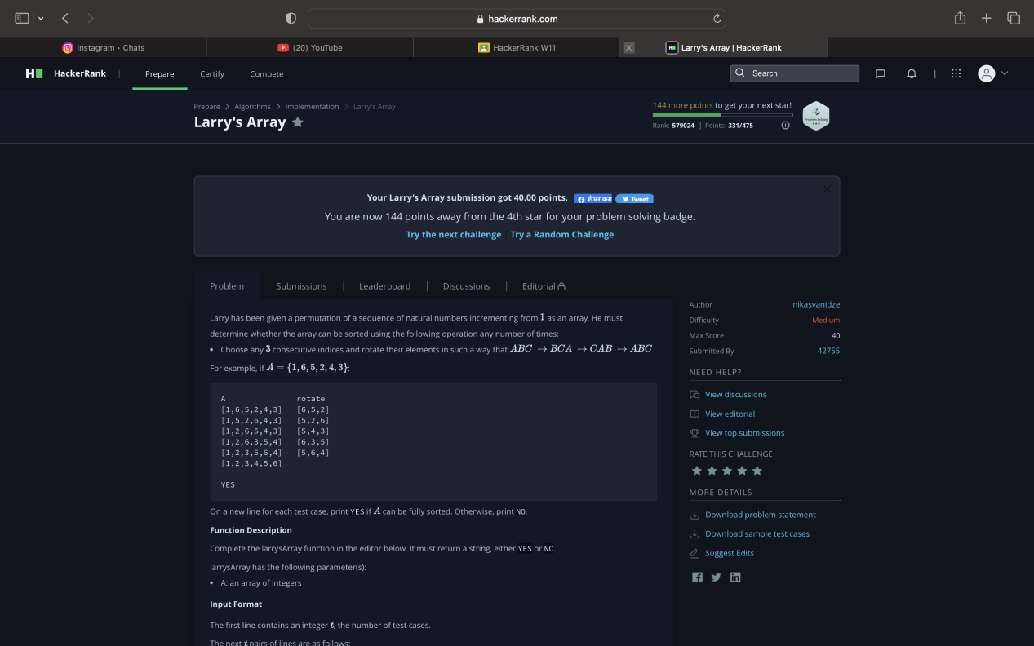

**Code:**

**import** sys

**def** canSort(l):

    s = **sorted**(l)

**for** i **in** s[:-2]:

**if** l.index(i) % 2:

            l.remove(i)

            l[0],l[1]=l[1],l[0]

**else**:

            l.remove(i)

**if** l[0]<l[1]:

**return** **True**

**else**:

**return** **False**

**if** __name__ == "__main__":

    t = **int**(sys.stdin.readline().strip())

**for** _ **in** **range**(t):

        n = **int**(sys.stdin.readline().strip())

        A = **list**(**map**(**int**, sys.stdin.readline().split()))

**if** canSort(A):

**print**("YES")

**else**:

**print**("NO")

**Output:**

